How to make email subscribe on the web page

Visit:https://wellsjohn220.github.io/Emailsub2025/

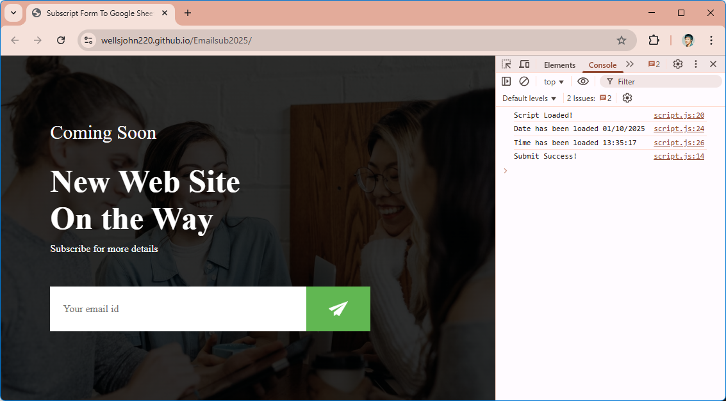

Source code from: https://github.com/wellsjohn220/Emailsub2025

Tutorial Video: https://www.youtube.com/watch?v=a8Om25FbaJA

